**Activity 1 -Filtering Data Part01**

**Exercise 1**

SQL Coding:

SELECT DISTINCT

employee_id

FROM employees;

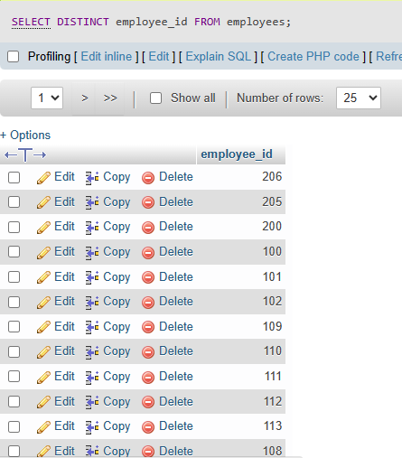

Total number of records: 40

**Exercise 2**

SELECT

employee_id, first_name, last_name, salary

FROM

employees

ORDER BY salary DESC

LIMIT 1;

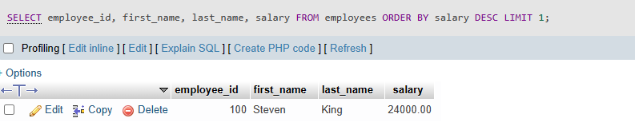

**Exercise 3**

SQL coding:

SELECT

department_id,

department_name

FROM departments

ORDER BY department_id

LIMIT 6 OFFSET 4;

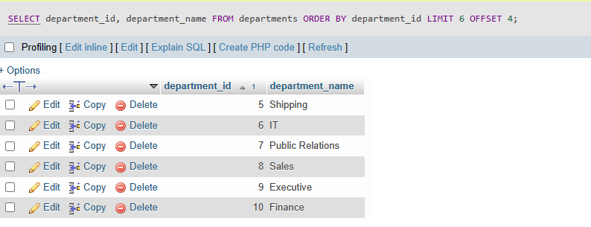

**Exercise 4**

SELECT DISTINCT

department_id

FROM departments;

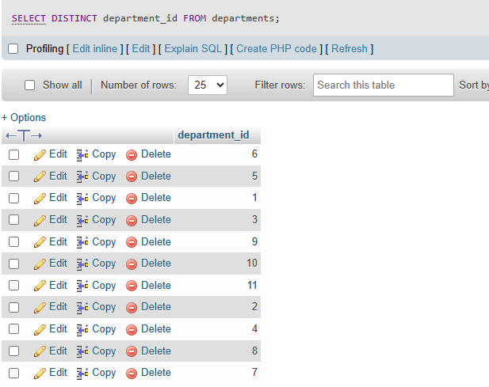

**Exercise 5**

SELECT

first_name,

last_name,

salary,

phone_number

FROM employees

WHERE

salary <= 5000;

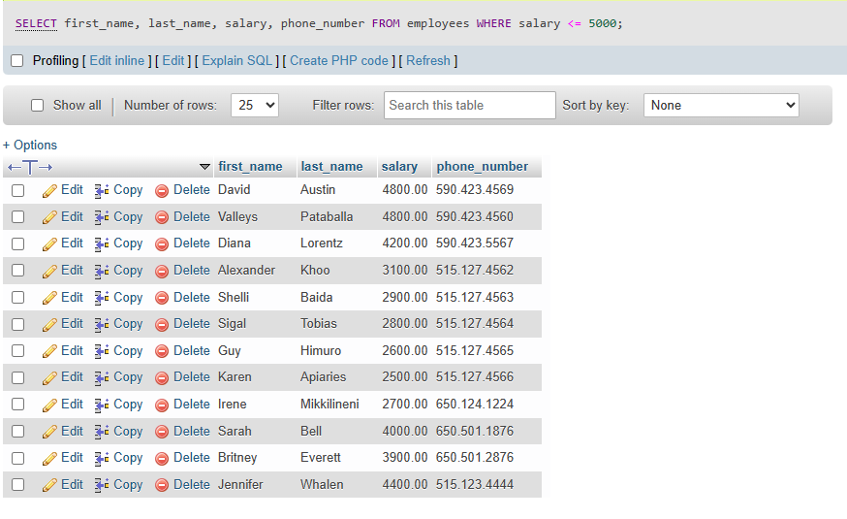

Exercise 6

SELECT

employee_id,

first_name,

last_name,

hire_date

FROM employees

WHERE

hire_date > 1999-01-01;

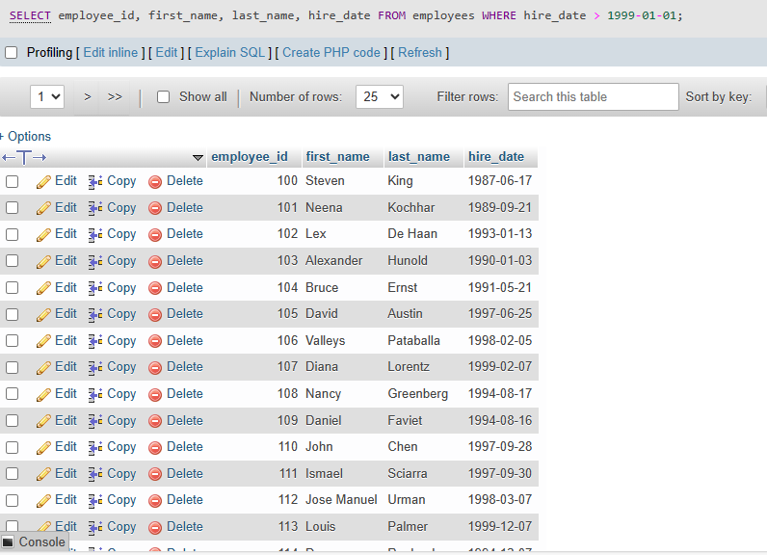

Total number of records: 21